Default Report  
*WTP For Green Electricity*  
**June 6th 2022, 1:06 pm CEST**

**Income - Aký je približný mesačný príjem Vašej domácnosti?**

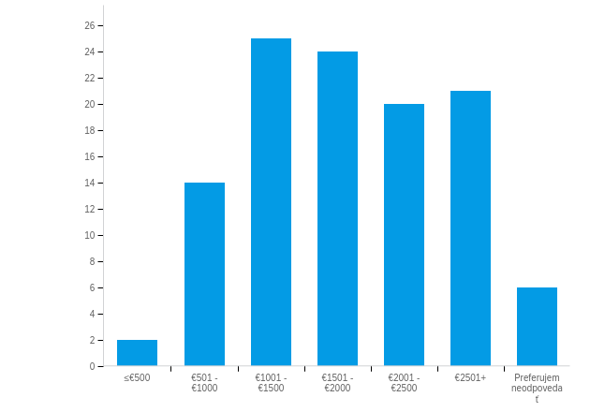

|  |  |  |  |  |  |  |  |
| --- | --- | --- | --- | --- | --- | --- | --- |
| # | Field | Minimum | Maximum | Mean | Std Deviation | Variance | Count |
| 1 | Aký je približný mesačný príjem Vašej domácnosti? | 1.00 | 7.00 | 4.19 | 1.50 | 2.26 | 112 |

|  |  |  |  |
| --- | --- | --- | --- |
| # | Answer | % | Count |
| 1 | ≤€500 | 1.79% | 2 |
| 2 | €501 - €1000 | 12.50% | 14 |
| 3 | €1001 - €1500 | 22.32% | 25 |
| 4 | €1501 - €2000 | 21.43% | 24 |
| 5 | €2001 - €2500 | 17.86% | 20 |
| 6 | €2501+ | 18.75% | 21 |
| 7 | Preferujem neodpovedať | 5.36% | 6 |
|  | Total | 100% | 112 |